# ­­my clinic

# Smart Appointment Booking – CRM Project

## Phase 9: Reporting, Dashboards & Security Review

* Goal: Deliver actionable clinical reporting and dashboards so clinic staff can monitor bookings, doctor utilization, cancellations, and patient onboarding — while enforcing secure access to sensitive data (sharing, field-level security, session/IP protections, and audit trail).

### 1. Reports (Tabular, Summary, Matrix, Joined)

* **Tabular Reports (simple lists)**

Upcoming Appointments – Next 7 Days

List of appointments scheduled in the next 7 days (date/time, doctor, patient, email, status).

Patient Master List

All patients (name, email, linked user, onboarding status) for admin reference.

* **Summary Reports (group & totals)**
* Appointments by Doctor – This Month: Appointments grouped by doctor with counts and a chart (utilization).
* Cancelled Appointments by Reason (Last 30 Days): Group by doctor or cancellation reason to see trends.
* **Matrix Reports (row/column pivot)**
* Doctor vs Week (Appointments Matrix) : Rows = Doctor, Columns = Week (or Day), cells = appointment counts (trend heatmap).
* Appointment Status by Day of Week : Rows = Status (Confirmed/Cancelled/Requested), Columns = Day of Week
* **Joined Reports (side-by-side comparisons)**
* Confirmed vs Cancelled — 30 Days : Block A = Confirmed appointments, Block B = Cancelled appointments (same date range) for side-by-side comparison.
* Patient Onboarded vs Not Onboarded : Block A = Admin-created patients, Block B = External/unlinked patients.

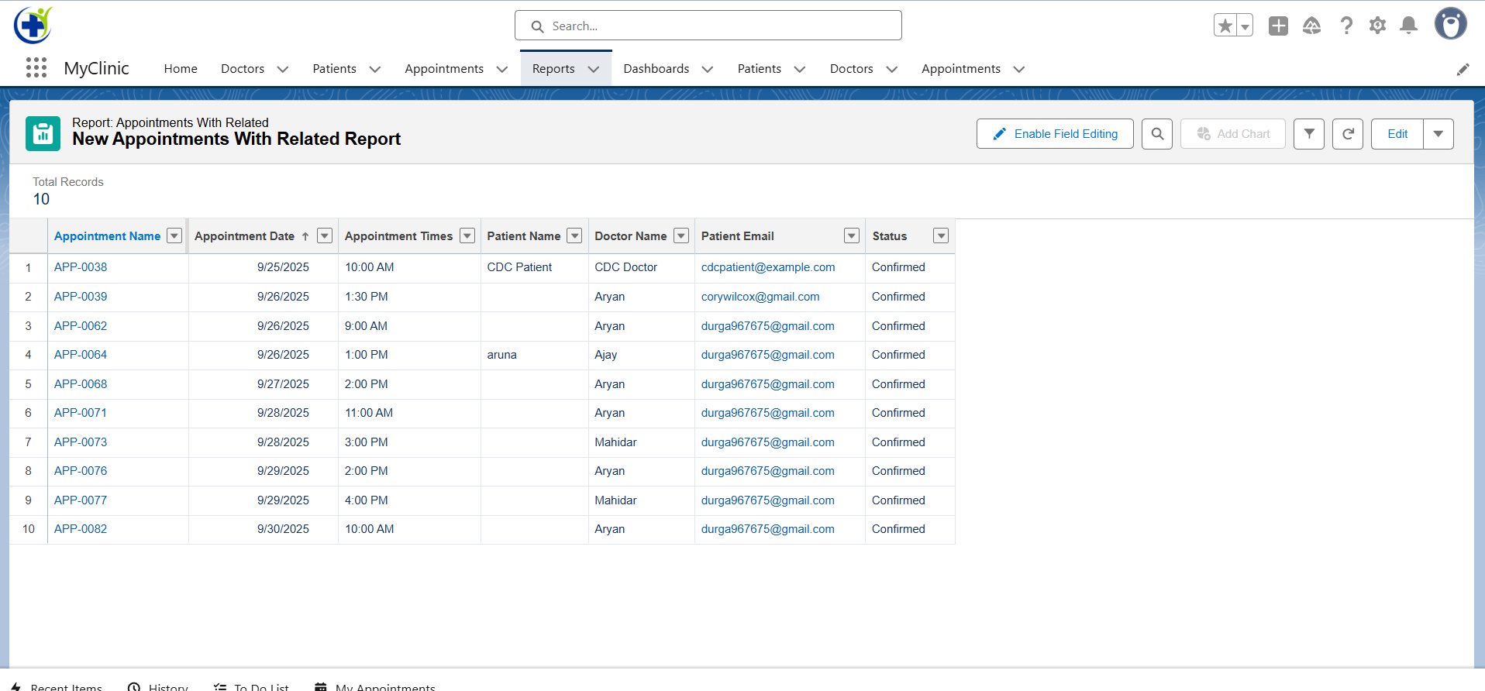

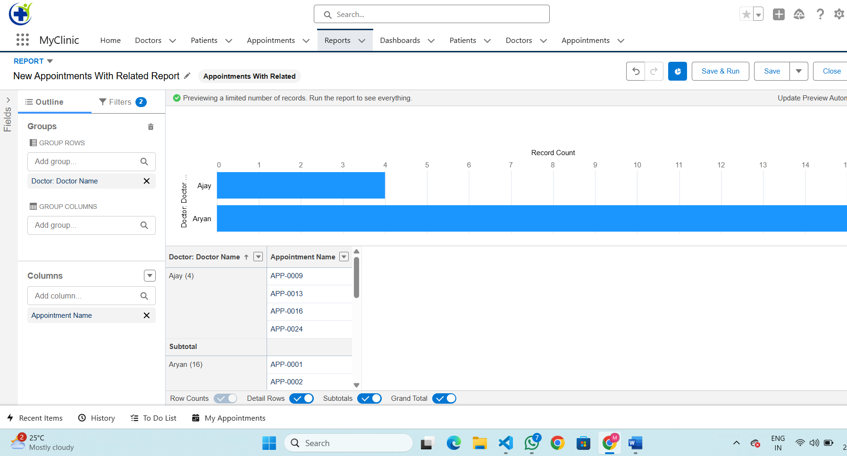

### 2.Report Types

* **Appointment Report Type**: Includes appointment details (date, time, status) with related doctor and patient info.
* **Doctor Report Type**: Links doctor records → appointments to track utilization and availability.
* **Patient Report Type**: Includes patient personal details, email, linked user information, and related appointments.
* **Follow-Up Report Type:** Links appointments → follow-up dates to track post-consultation care.

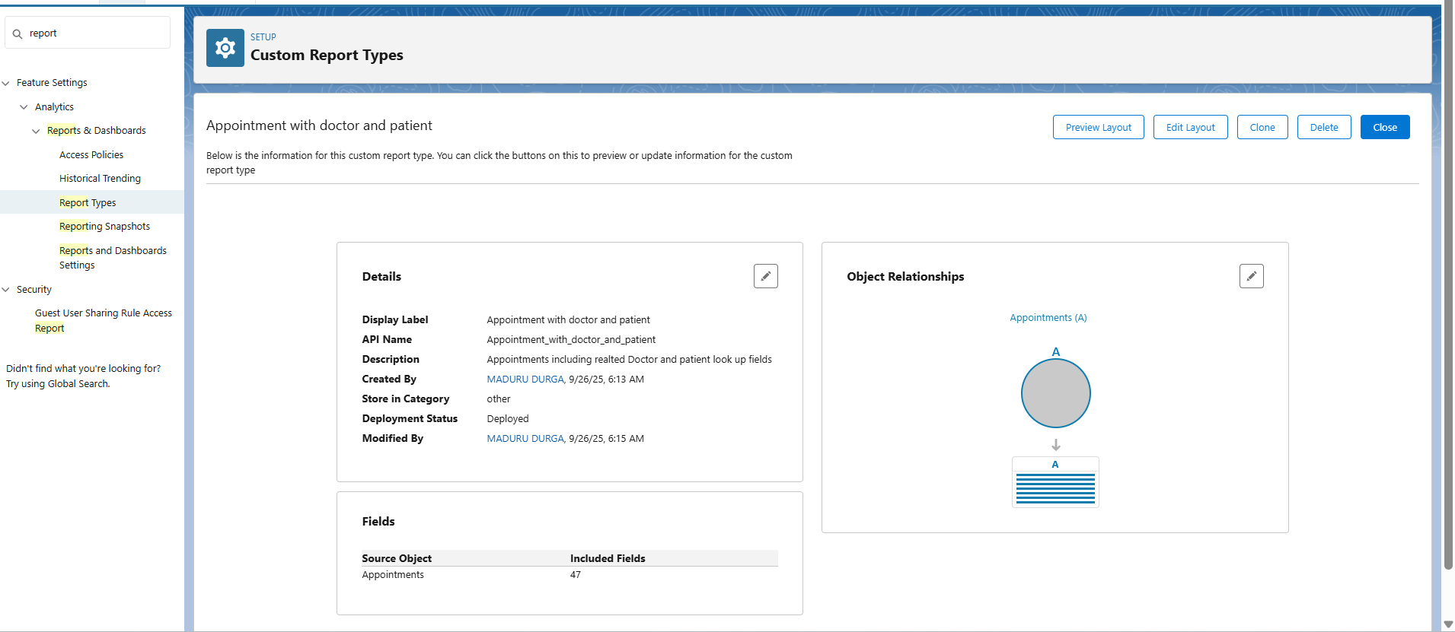

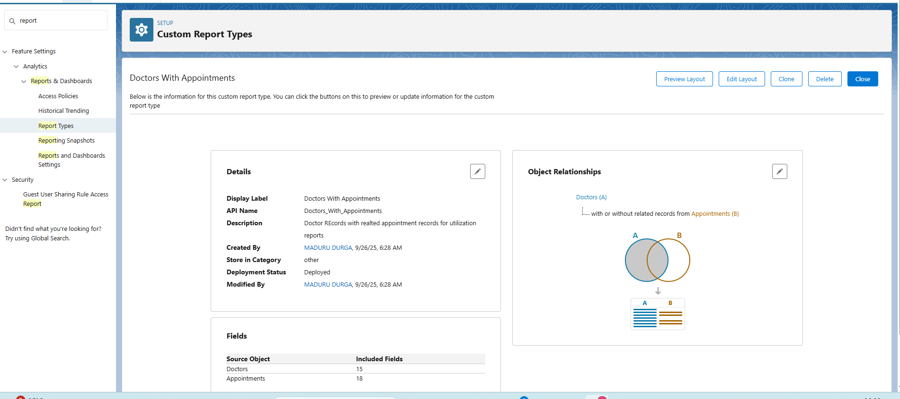

### 3. Dashboards

* Clinic Overview Dashboard: Total Patients, New Onboards, No-shows / Cancellations, Daily Appointments.
* Appointment Attendance Dashboard: Confirmed %, Cancelled %, No-show % and day-of-week patterns.
* Doctor Utilization Dashboard: Appointments per doctor, top-performing doctors, average appointment load.
* Booking Trends Dashboard: Daily/Weekly booking trends and most popular time slots/doctors.

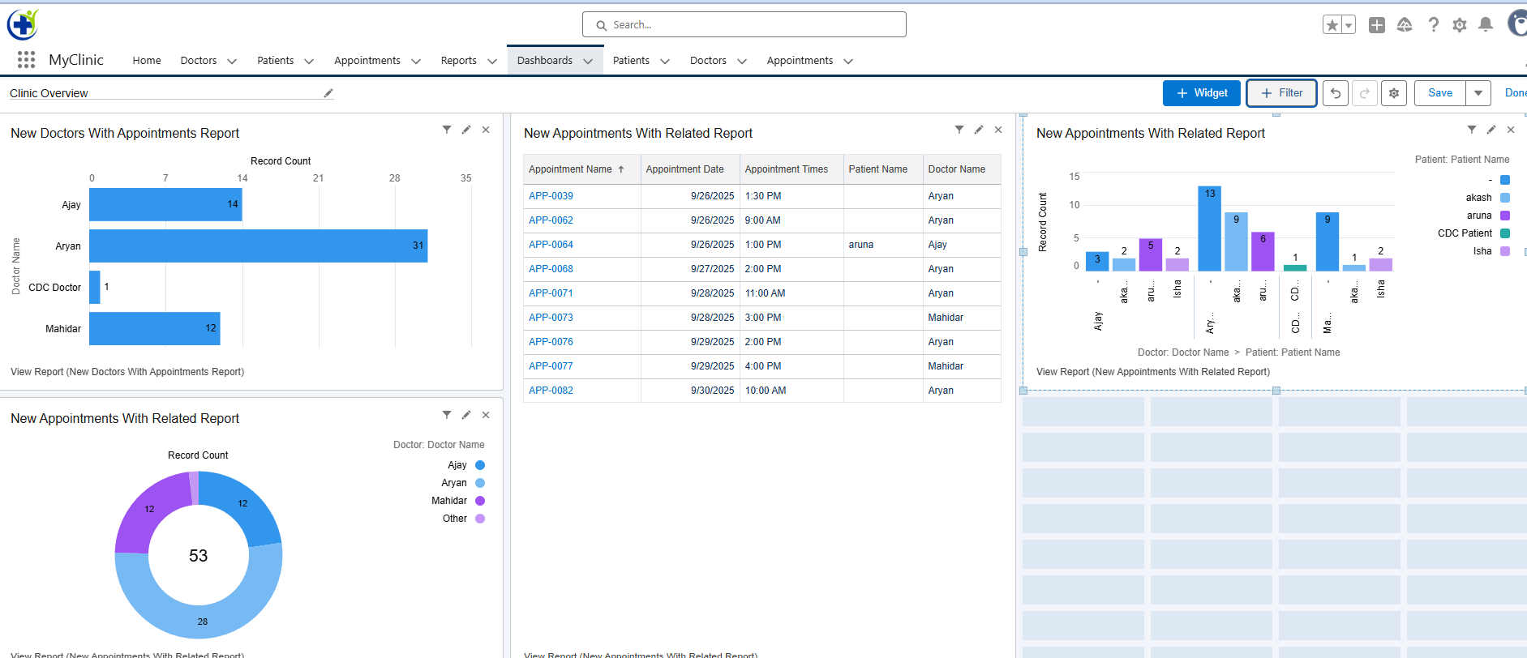

### 4. Dynamic Dashboards

* Configured dashboards to run as the logged-in user so each Doctor sees only their own appointment data, Clinic Manager sees aggregated clinic data, and Admin sees full org data.
* Applied dashboard filters (Doctor, Appointment Date, Status) for real-time drill down and on-the-fly comparisons.

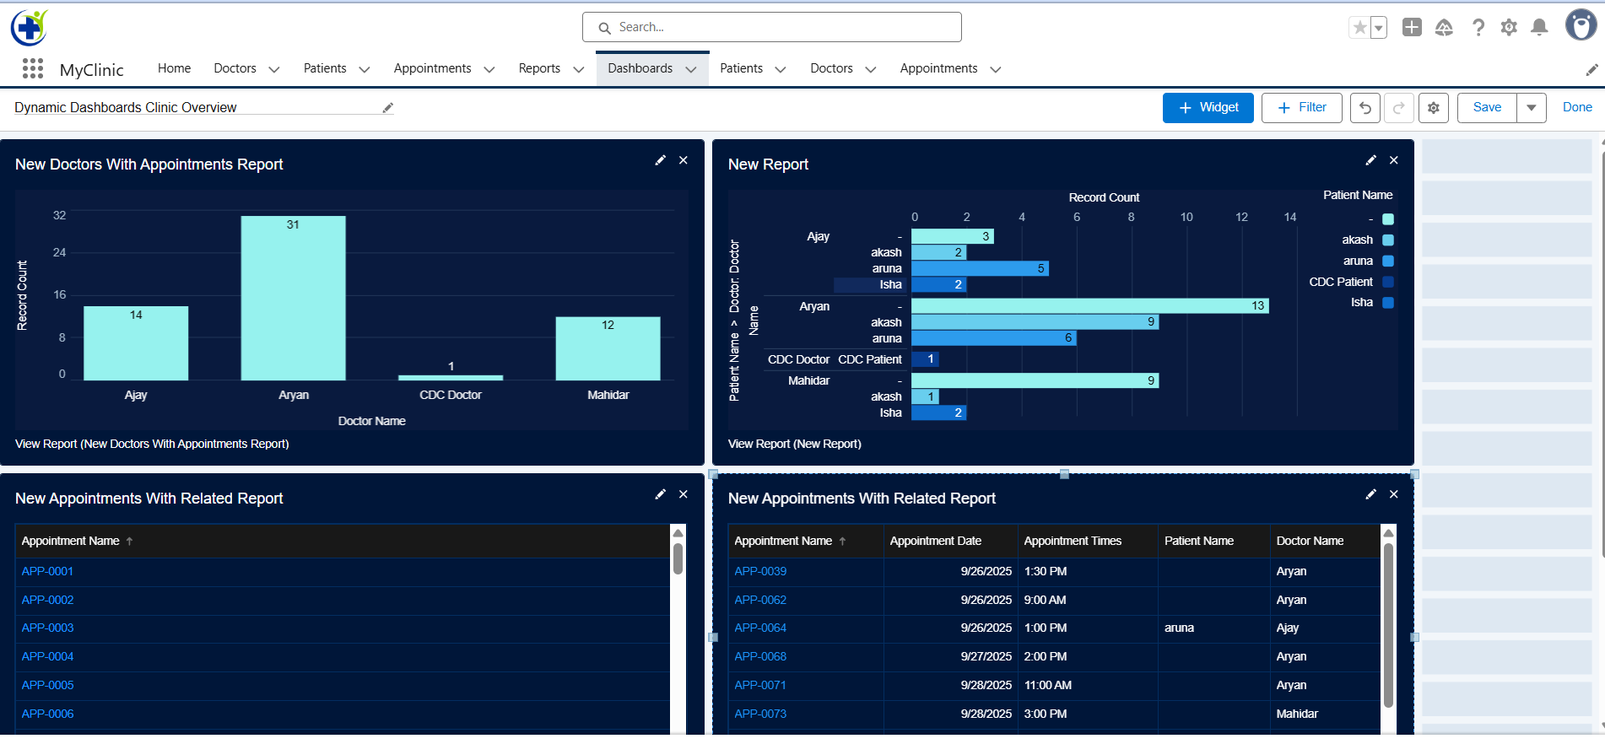

### 5. Sharing Settings

* **Organization-Wide Defaults (OWD):**
  + Appointments, Patients = Private
  + Doctors = Public Read Only
  + Appointments = Controlled by Clinic Manager or Admin.

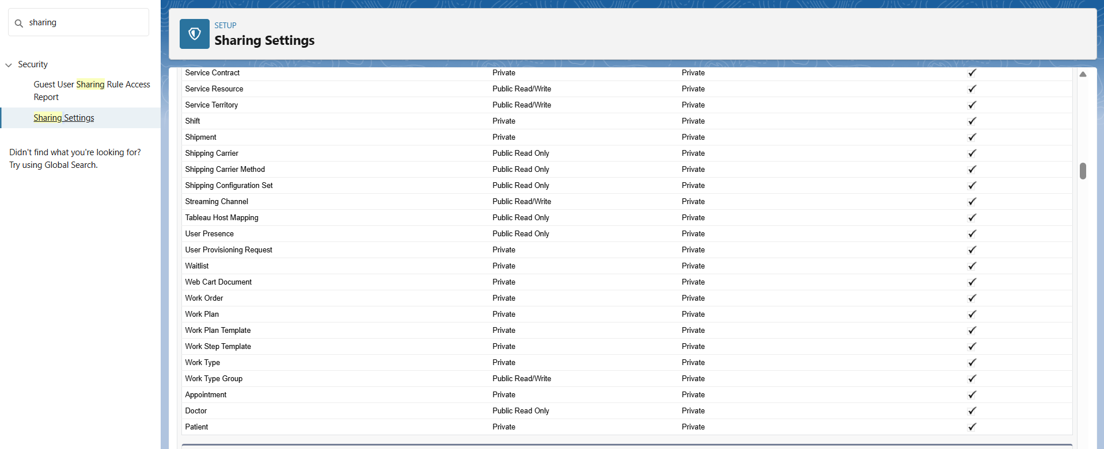

* **Role Hierarchy:**
  + Admin > Clinic Manager> Doctor > Patient

* **Sharing Rules :**
* Criteria-based: Confirmed appointments shared with respective Doctor roles.
* Owner-based: All appointments owned by doctors are visible to Clinic Manager.

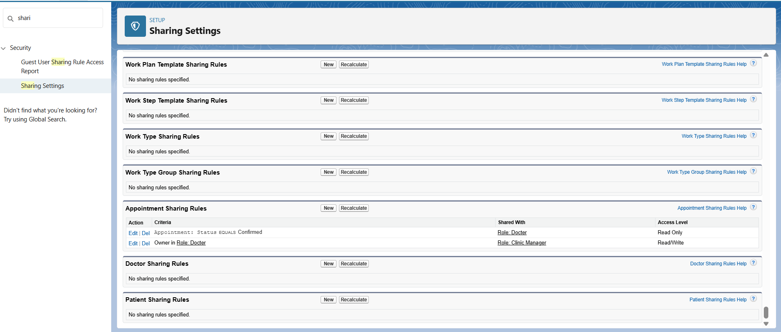

### 6. Field Level Security

* Patient Contact Info (Email, Phone) → Admin & Clinic Manager only.
* Other Patient Appointments → visible to admin only.
* Doctor Notes → Visible to Doctors & Admin, hidden from Patients.
* **Profiles Configured:**

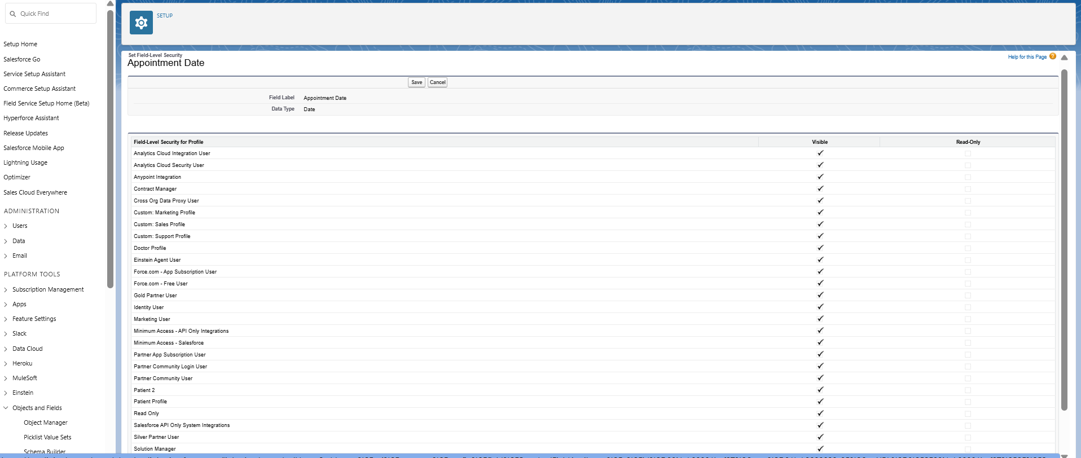

### 7. Session Settings

* Session Timeout configured to 30 minutes.
* Logout on Timeout enabled to prevent unauthorized access.
* Lock Session to IP enforced for additional security.
* Clickjack & CSRF Protection enabled to safeguard against attacks.
* HTTPS Required to ensure secure data transmission.

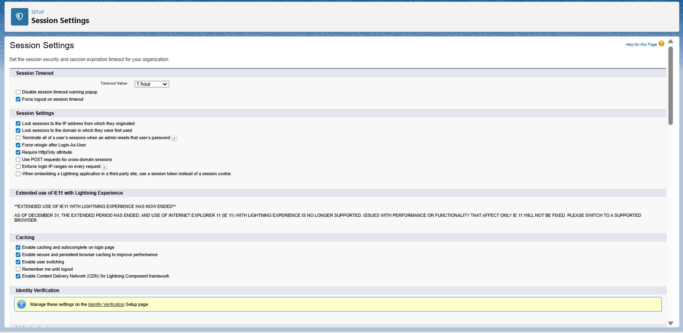

### 8. Login IP Ranges

* **Network Access (Org-wide)**: Added trusted clinic office/Wi-Fi public IP range so internal users bypass identity challenges.
* **Profile-Specific Ranges:**
  + Doctors — Allowed only from clinic network and approved VPN ranges.
  + Admin / Clinic Manager — Allowed from office network + VPN ranges.
  + Patients — Left open (or configured broader ranges) so patients can access the portal from home/mobile as needed.

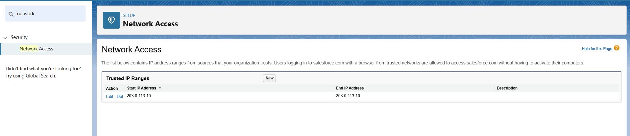

### 9. Audit Trail

* **Setup Audit Trail**: Reviewed and downloaded recent changes to roles, profiles, sharing settings and flows for compliance.
* **Field History Tracking**: Enabled for key objects (Appointment_c, Patient_c). Tracked fields include Status, Appointment Date, Appointment Time, Doctor, Follow Up Date, and Patient Email. Field history is available in the Appointment History and Patient History related lists.
* **Login History**: Monitored failed and suspicious login attempts; exported CSVs for audit and security review.

